| **Product Category** | **Make Icon with Description** |
| --- | --- |
| **Operation Theater**  **(Make Icons by your own)** | | **Products with 3D Icons** | | --- | | * Modular Operation Theater (MOT) | | * Operating Tables (Electric/Manual) & OT Lights, * Surgical Pendants * Suction Units. | | * Laryngoscope / Video Laryngoscope & Video Bronchoscope (Airway Management System) | | * Surgical Instruments (General, Laparoscopic, Orthopedic Sets) & Surgical Holloware * Electrosurgical Units. | | * Patient Warming System. | | * Patient Transfer Trolleys * Instrument Trolleys, Mayo Stands, Surgeon Stools & Stainless Steel Utility Cabinets. | |
| **ICU / Ward**  **(Make Icons by your own)** | | **Products with 3D Icons** | | --- | | * Multiparameter Patient Monitors (Bedside & Central), * ECG Machines * Pulse Oximeters * Capnography (ETCO2) | | * Syringe & Volumetric Infusion Pumps. | | * ICU Electric Beds (Advanced) & General Ward Beds (Manual/Semi-Electric) * Bedside Lockers & Over-Bed Tables. | | * Medical Carts (Utility/Dressing). | |
| **Diagnostic**  **(Make Icons by your own)** | |  | **Products with 3D Icons** | | --- | --- | | * X-Ray Image Viewers. | |  | |  | * BP Apparatus (Digital/Aneroid) * Stethoscopes * Spirometers * Diagnostic Sets | |
| **Emergency**  **(Make Icons by your own)** | | **Products with 3D Icons** | | --- | | * Defibrillators & AEDs | | * Emergency Stretcher & Cart | |  | |
| **Gyne & Nursery**  **(Make Icons by your own)** | | **Products with 3D Icons** | | --- | | * Labor/Delivery/Recovery Beds * Fetal Monitors. | | * Infant Incubators, Radiant Warmers &Phototherapy Units * Infant / Adult Weighing Scales. | | * Examination Couches, * Delivery Table / Bed * Infant Cribs and Cots | |
| **https://totalgroup.com.pk/** | **references** |
| **Medical Gas Pipeline System (MGPLS)**  **(Make Icons by your own)** | | **Products with 3D Icons** | | --- | | * Full MGPS Installation (Design, Testing, Commissioning, Certification), Pipeline Maintenance. | | * Medical Air Compressor Plants * Central Vacuum Pump Stations, * Gas Manifolds (Oxygen, Nitrous Oxide). | | * Master / Area Alarm Systems, * Pressure Regulators / Flow-Meter, * Gas Outlets(Oxygen, Nitrous Oxide & Air)., * AGSS System * Bed Head Units. | | * Oxygen / Nitrous Gas Cylinder | |
| **CSSD System**  **(Make Icons by your own)** | | **Products with 3D Icons** | | --- | | * Steam Autoclaves * Low-Temperature Plasma Sterilizers * Scrub Units. | | * Washer-Disinfectors * Ultrasonic Cleaners. | | * Sealers * Instrument Trays and Baskets * Sterilization Wraps and Pouches. | | * Chemical and Biological Indicators, * Bowie-Dick Test Packs | | * Complete CSSD Furniture. | |

**Website Changes:**

1. **Kindly Change the customer first philosophy with Caring for life . kindly consult to Adeel.**
2. **Please remove following.**



1. 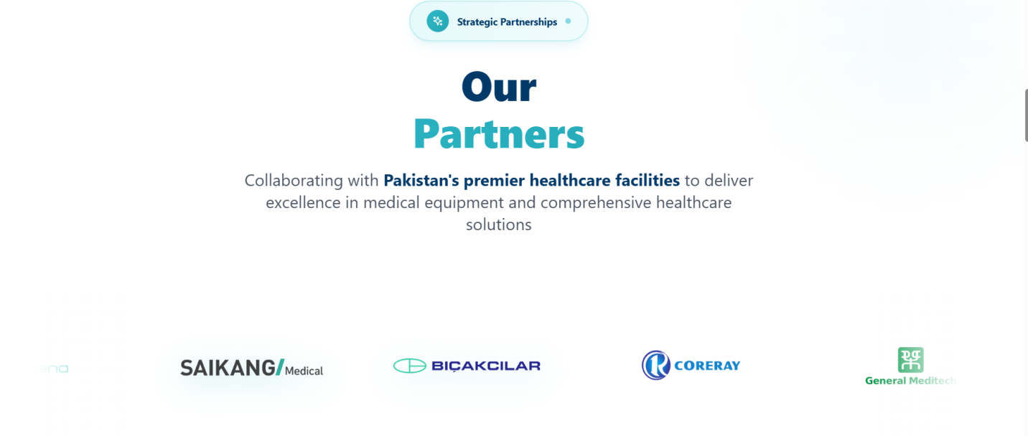**Our Partners:**

* **As we are exclusive distributor in the Pakistani market, we select and deliver cutting-edge medical equipment from international partners, ensuring premier healthcare facilities have access to world-class technology and sustained excellence in patient care.**

1. **Our Clients**

* **Most of Pakistan's Premier Hospitals and Leading Healthcare Institutions** **who trust Medap International.**



1. **Delete these.**

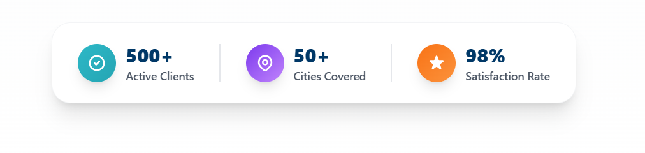

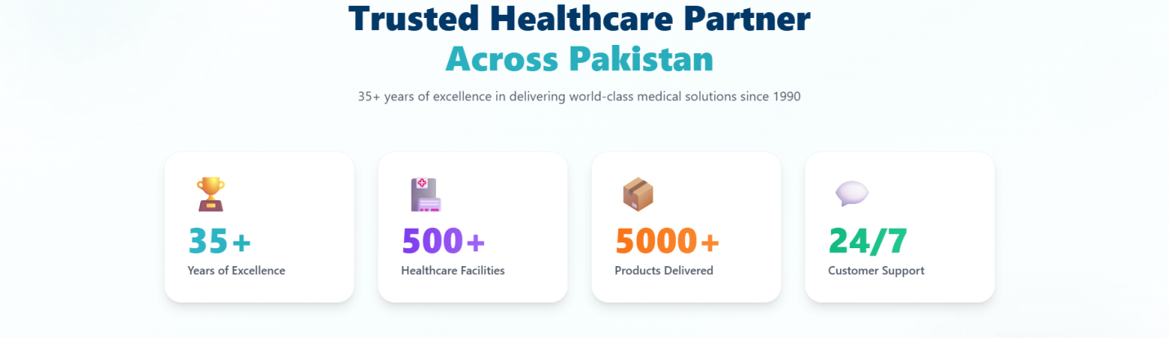



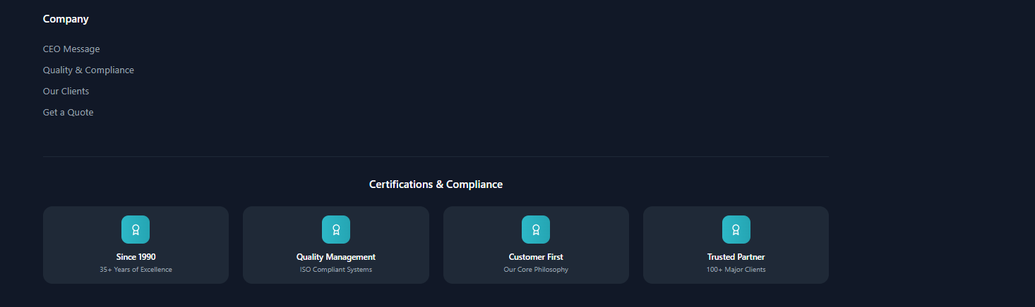

1. Change this

